Assignment 9

Problem 1

Before Revision (Initial Stages)

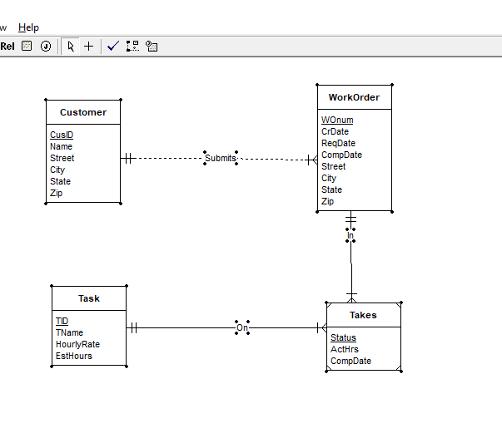

After Revision (Refined)

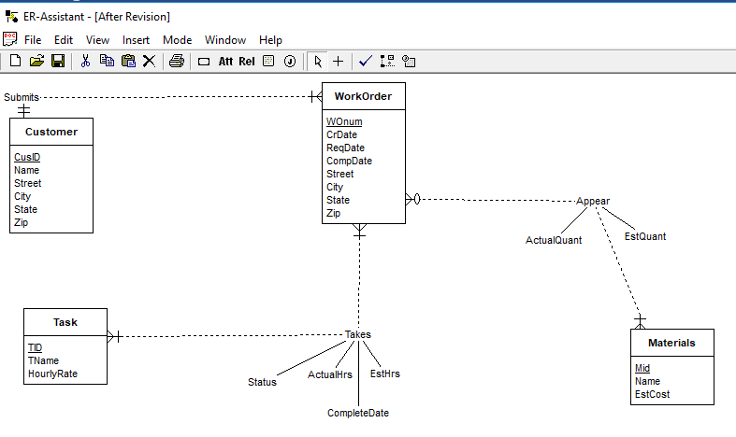

Changes:

* A new Entity type Materials is added with a primary key.
* This has a M-N relationship with WorkOrder. So this is presented using an Associative Entity type Appear, with Identifying relations between WorkOrder-Appear and Materials-Appear
* Estimated Hours Attribute(EstHrs) which was initially in Task Entity is now changed into Takes Entity, since now EstHrs depend on both Task and WorkOrder.